Demonstrations of Virtual Worlds for Education Research at NDSU
Brian M. Slator, Jeffrey Clark, Paul Juell, Phil McClean, Bernhardt Saini-Eidukat, Donald P. Schwert, Alan R. White, John Bauer, Francis Larson, Bradley Vender, Aaron Bergstrom, Otto Borchert, Robert Cosmano, Justin Hawley, Christina Johnson, John Opgrande, Rebecca Potter, Paul Rye, Lester Sjoblom, Shannon Tomac, and the NDSU Worldwide Web Instructional Committee (WWWIC)
North Dakota State University
Fargo, ND 58105

Abstract
The World Wide Web Instructional Committee (WWWIC) at North Dakota State University (NDSU) is an ad hoc group of university faculty dedicated to developing internet-based education and research software. Members of this group foster cross-disciplinary, collaborative relationships with WWWIC faculty, students, and staff as well as those from other universities and institutions. The content of WWWIC immersive environment projects includes subject matter across a variety of disciplines such as anthropology, archaeology, cell biology, commerce, computer science, geology, and history. WWWIC's projects include the Virtual Cell for cell biology education, the Geology Explorer for geology education, and the Digital Archive Network for Anthropology for archaeology and anthropology education, as well as others. This paper will highlight many of these.

Introduction
The NDSU World Wide Web Instructional Committee (WWWIC; McClean et al., 1999) is engaged in several virtual/visual research and development projects: some are NSF-supported, the Geology Explorer (Schwert et al., 1999), the Virtual Cell (White et al., 1999) the Visual Computer Program (Juell, 1999) and the ProgrammingLand MOOseum of Computer Science (Slator and Hill, 1999). Each has shared and individual goals. Shared goals include the mission to teach science structure and process: the scientific method, scientific problem solving, diagnosis, hypothesis formation and testing, and experimental design. The individual goals are to teach the content of specific scientific disciplines: Geology, Cell Biology, Computer Science. In addition, WWWIC is applying what has been learned in Science education to new domains: history, microeconomics, and anthropology.

The Geology Explorer
The Geology Explorer project implements a virtual world where learners assume the role of a geologist on an expedition to explore the geology of a mythical planet. Learners participate in field-oriented expedition planning, sample collection, and "hands on" scientific problem solving. The Geology Explorer world, Planet Oit, is simulated on an Object Oriented Multi-user Domain, the Xerox PARC LambdaMOO. A text-based version of Geology Explorer was tested in an introductory geology class during the Summer 1998. Results of that test were used to prepare for a larger test in the same geology class during Fall 1998 and Fall 1999. A graphical user interface to the Geology Explorer is under development.

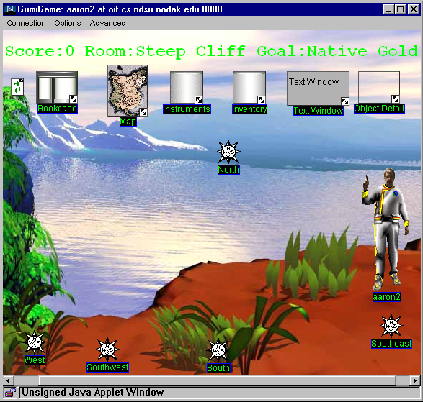
Figure 1: Students explore the Planet seeking to achieve authentic goals.

To play the game, students are transported to the planet's surface and acquire a standard set of field instruments. Students are issued an "electronic log book" to record their findings and, most importantly, are assigned a sequence of exploratory goals. These goals are intended to motivate the students to view their surroundings with a critical eye, as a geologist would. Goals are assigned from a principled set, in order to leverage the role-based elements of the game. The students make their field observations, conduct small experiments, take note of the environment, and generally act like geologists as they work towards their goal of, say, locating a kimberlite or a graphite deposit. A scoring system has been developed, so students can compete with each other and with themselves. The Geology Explorer prototype can be visited at http:/ /oit.cs.ndsu.nodak.edu/

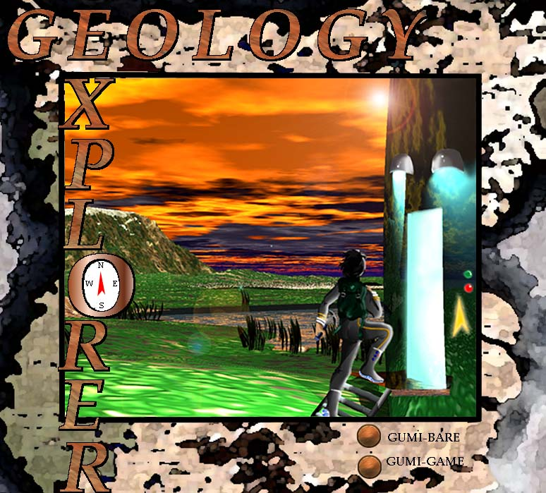
Figure 2: The Geology Explorer is self-paced and immersive.

The Virtual Cell
The Virtual Cell (VCell) is an interactive, 3-dimensional visualization of a bio-environment. VCell has been prototyped using the Virtual Reality Modeling Language (VRML), and is available via the Internet. To the student, the Virtual Cell looks like an enormous navigable space populated with 3D organelles. In this environment, experimental goals in the form of question-based assignments promote diagnostic reasoning and problem-solving in an authentic visualized context.

Figure 3: students in the Virtual Cell are given instructions in the Lab.

The initial point of entry for the Virtual Cell is a VRML-based laboratory. Here the learner encounters a scientific mentor and receives a specific assignment. In this laboratory, the student performs simple experiments and learns the basic physical and chemical features of the cell and its components. More notably, our laboratory procedures are crafted such that they necessitate a voyage into the Virtual Cell where experimental Science meets virtual reality. As the project progresses, students revisit the laboratory to receive more assignments. Periodically, the student will bring cellular samples back to the virtual lab for experimentation. The Virtual Cell prototype can be visited at http://vcell.ndsu.edu

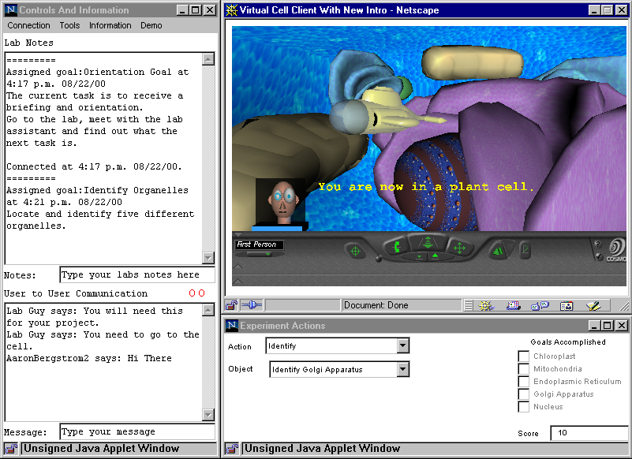
Figure 4: The students explore the Virtual Cell alone or in small groups.

The Archaeology Technologies Laboratory
The Archaeology Technologies Laboratory (ATL) at NDSU was founded for the purpose of developing a 3D artifact scanning protocol and digital databases. The ATL equipment includes a Minolta Vivid 700 laser 3D digitizer, top-end workstation and laptop computers, and PolyWorks Modeler software. With the assistance of graduate and undergraduate students, NDSU IT staff, and consulting colleagues in computer science, the ATL has made significant progress in developing databases for Samoan lithics and hominid cranial endocasts. These databases are serving as the test cases to work out the scanning and modeling procedures, database structure, user interface, system architecture, navigation system, and other desirable features of an archive network.
At the ATL, we are working to create an Internet-based digital archive for anthropology that contains accurate, 3D models of material objects. These models will be sufficiently precise to allow for measurements at the micron level, thus permitting a wide range of detailed analyses through the application of specially created “virtual tools.” Our ultimate goal is to work with other institutions to create a network of interoperable databases forming a global Digital Archive Network for Anthropology (DANA). Such a federation of databases would link researchers, students, and the general public to realistic, accurate, visual representations of artifacts, fossils, and other archived objects. ATL can be visited online at http://atl.ndsu.edu.

Figure 5: Archeological artifacts are stored in a 3D database.

Fort Berthold and Like-a-Fishhook
The Fort Berthold project is an attempt at the construction of a virtual, immersive, multi-user, spatially oriented, exploratory environment, such as we have constructed in the past. First version is text-based, with migration to graphical interface written into the project plan. The aim is to create an active and educational space where visitors are engaged in goal-based tasks that promote exploration and problem-solving: the usual thrust. In other words, this is NOT a museum piece where people come to wander around and passively look at things. Visitors will be engaged in a) geology, or b) archeology, or c) botany, or d) nutrition.
The simulation will model North Dakota’s Fort Berthold and Indian Village, which was excavated in the 1950s and then flooded by the Garrison Dam project, shortly thereafter. Working from archeological records, we plan to simulate this valuable historical site in an internet-based, immersive 3D application.

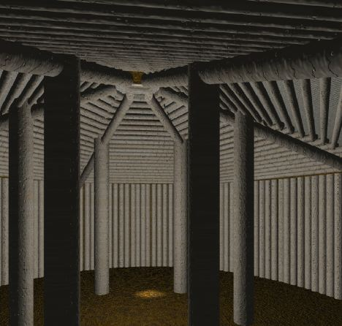
Figure 6: The Fort Berthold simulation includes “remarkable earth and timber lodges”

Blackwood
The Blackwood Project is the first attempt at the "next generation" of role-based virtual environments for education where the pedagogical simulation will support cross disciplinary content and choice of roles to promote player interaction and potential collaborations. This next generation will build on experience gained in designing and implementing earlier virtual environments.
The Blackwood Project seeks to recreate a virtual 19th century Western town intended to teach American History and Microeconomics. This town will be populated with software agents to simulate an economic environment, and with software tutors to support our educational strategies. The system will be hosted on the Internet and will provide opportunities for research into distance education, intelligent agents, economic simulation, and assessment of pedagogical approaches.

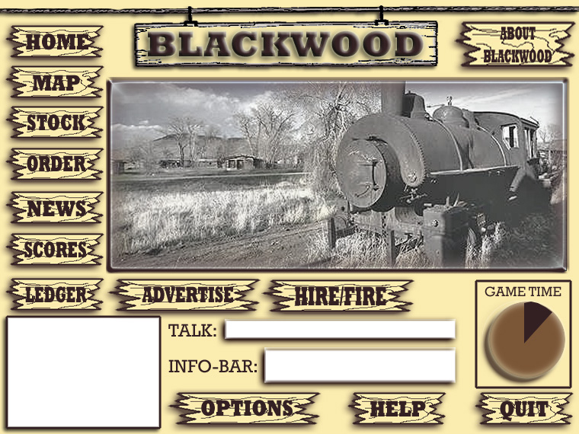
Figure 7: Blackwood combines business with history.

References
- Juell, Paul (1999). Educational Opportunities Using VRML in the AI Classroom. Intl. Conf. on Mathematics/ Science Education & Technology (M/SET-99), March 1-4, 1999, San Antonio, TX, pp. 119-123.
- McClean, Phillip E. , Donald P. Schwert, Paul Juell, Bernhardt Saini-Eidukat, Brian M. Slator, Alan R. White. (1999). Cooperative Development of Visually-Oriented, Problem-Solving Science Courseware. Intl. Conf. on Mathematics/ Science Education & Technology (M/SET-99), March 1-4, 1999, San Antonio, TX, pp. 486-491.
- Schwert, Donald P., Brian M. Slator, Bernhardt Saini-Eidukat, (1999). A Virtual World For Earth Science Education In Secondary And Post-Secondary Environments: The Geology Explorer. Intl. Conf. on Mathematics/ Science Education & Technology (M/SET-99), March 1-4, 1999, San Antonio, TX, pp. 519-525.
- Slator, Brian M. and Curt Hill (1999). Mixing Media For Distance Learning: Using IVN And Moo In Comp372. World Conference on Educational Media, Hypermedia and Telecommunications (ED-MEDIA 99), June 19-24, Seattle, WA, pp. 881-886.
- White, Alan R., Phillip McClean, and Brian M. Slator (1999). The Virtual Cell: A Virtual Environment for Learning Cell Biology. Proc. of the Tenth Intl. Conf. on College Teaching and Learning: Innovation in a Global Learning Community. April 14-17. Jacksonville, Florida.

Acknowledgements
The NDSU World-wide Web Instructional Committee (WWWIC) research is currently supported by funding from the National Science Foundation under grants DUE-9981094 and EIA-0086142, and from the US Department of Education under grant P116B000734.

