JavaMOO Virtual Cells for Science Learning

Otto Borchert
North Dakota State University, USA
Ben Dischinger
North Dakota State University, USA
Guy Hokanson
North Dakota State University, USA
Phillip E. McClean
North Dakota State University, USA
Brian M. Slator
North Dakota State University, USA
Bradley Vender
North Dakota State University, USA
(in alphabetical order)

Abstract
One of the World Wide Web Instructional Committee (WWWIC) at North Dakota State University’s (NDSU) long running projects is the Virtual Cell, a desktop immersive virtual environment developed for biology education. The focus of the content in the Virtual Cell is cellular biology, and the underlying focus of the content modules is the scientific method and analytical reasoning. However, the technical challenges encountered during the course of the project include designing deployable server architectures, designing robust simulations, and developing high quality animations without losing interactivity.

Keywords
Computer-Based Instruction, Education Research, K-12 Education, Internet-Based Instruction, Online Games, Virtual Learning, Virtual Reality, Educational Technology, Simulation and Modeling

Introduction
The World Wide Web Instructional Committee (WWWIC) at North Dakota State University (NDSU) is engaged in research aimed at developing virtual environments to assist in the education and growth of students (Slator et al., 1999). Some of the key factors that lead to the success of these environments are a) the theory of role-based environments on which they are based, b) the use of graduate and undergraduate students in the development process, c) the use of the environments in actual classes, and d) the application of knowledge from one environment to the others.
An educational game should be both engaging and informative. Players should acquire concepts and skills because of playing the game, and this learning should transfer to contexts outside the game. The challenge then is to construct a game of sufficiently interesting complexity that is consistent with the subject it attempts to teach. When the player acts in the simulated environment, the environment must re-act in coherent and plausible ways. Without this consistency, the game will fail the ultimate test: students will not play it (Slator & Chaput, 1996).
Virtual role-playing environments can be a powerful mechanism of instruction, provided that they are constructed such that learning how to play and win the game contributes to a player's understanding of real-world concepts and procedures. WWWIC has developed environments to enhance student understanding of geology (Planet Oit), cellular biology (Virtual Cell), programming languages (ProgrammingLand), retailing (Dollar Bay), and history (Blackwood). These systems present a number of opportunities and challenges. Players are afforded a role-based, multi-user, ‘learn-by-doing’ experience, with software agents acting as both environmental effects and tutors, and the possibilities of multi-user cooperation and collaboration. The Virtual Cell environment, its particular challenges, and the solutions to these are presented.

The Virtual Cell
The Virtual Cell as implemented is a client server system where the server is responsible for the persistence of the shared environments, arbitrating state changes, and facilitating communication between players. The client is responsible for constructing the appropriate view of each shared environment and for providing the user interface elements appropriate to each environment and task. In order to display the environments, the primary role of the client is to load and display the scenes which are stored on the server and that compose that environment. As a result, the client’s scene loading algorithm shapes how the client and server interact.
In the Virtual Cell, the basic element of the game is the goal. A goal represents either a single objective or a group of simple related objectives that the player is tasked to achieve, or a set of steps which the player is tasked with achieving. Also associated with each goal is a set of reference materials to explain various aspects of the activity that the player should be attempting to accomplish. 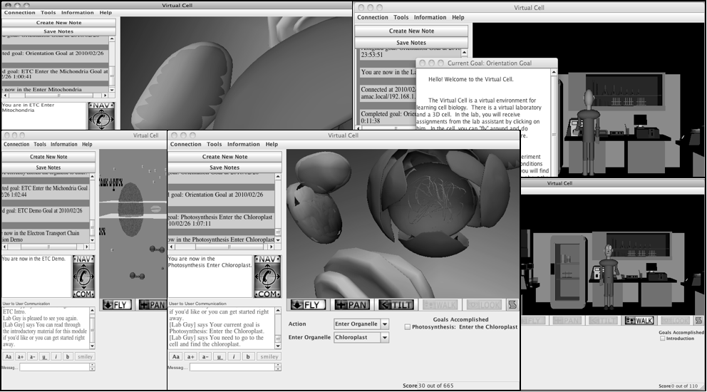
Figure 1. Various Scenes in the Virtual Cell
Goals are grouped together into a sequence to form a module, and the module is the format in which are presented to players and instructors. At the midpoint of the project’s current history, the Virtual Cell had three modules: (1) Organelle Identification, (2) Electron Transport Chain, and (3) Photosynthesis. The Organelle Identification module is used as an introduction to the game play and the acts of performing tests and comparing results. The Electron Transport Chain (ETC) module focuses on one part of the respiration process and traces the movement of hydrogen and electrons during the conversion of adenosine diphosphate (ADP) to adenosine triphosphate (ATP) in the mitochondria. The Photosynthesis module similarly focuses on the movement of hydrogen and electrons in one segment of the photosynthesis reaction in the chloroplast.
The Organelle Identification module is an introduction to the game and begins with the simple task of flying around the cell to collect assay results from each organelle. The two follow-up tasks for this module are simple diagnostic tasks in which the player is asked to verify a diagnosis by collecting further results and comparing the experimental or actual results to expected values.
The more elaborate Electron Transport Chain (ETC) module consists of a sequence of introductory tasks leading up to a more complicated diagnostic task. Much like a lab exercise, the introductory tasks in this module present the expected behavior of the individual components of the system and gradually combine the pieces together to help the player build up a model of how the system operates. The diagnostic task at the end of the module serves to test the expected understanding by presenting the player with a malfunctioning version of the system and asking the player to identify replace the defective components to restore proper behavior.
The Photosynthesis module for the Virtual Cell in its current form differs from the ETC module by having a final task, inducing an inactive section of the chloroplast to produce ATP, is one of process replication instead of diagnosis. In order to accomplish the goal, the player is asked to add the necessary photons and substrates to the system and induce a temporary imbalance in the hydrogen equilibrium, and as a side effect of the hydrogen imbalance being removed, the system will produce ATP from ADP. The crucial difference being that this photosynthesis activity requires the player to interact with the same system over a sequence of dependent steps, rather than the parallel independent steps used in the ETC.
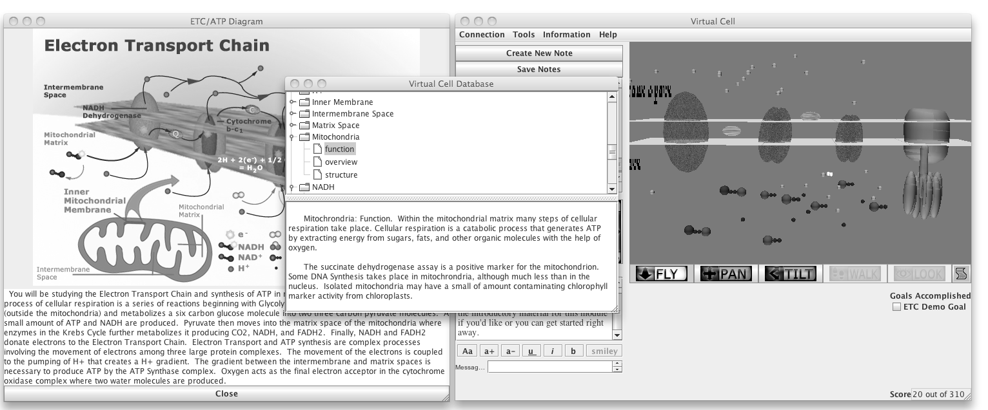
Figure 2. Sample Additional Information Sources Available in the Game
As the player works through each module, a help and information system is available to supplement the interactive activities. In that system, the player can find descriptions of the system being studied and information about the structures and chemicals involved. For example, in the ETC module, as shown in figure two the player has access to overview diagrams such as the one one the left, the reference database shown in the middle, and an animated demonstration version of the system shown on the right.
One of the major goals of WWWIC research is to find ways to provide tutoring agents to communicate expert advice to students as they progress through the environment. These agents monitor the student and send advice as needed while being careful to never insist upon or block any course of action (Slator, 1999).
Feedback for the diagnostic activities is divided into four categories using the orthogonal characterizations of correctness and sufficiency of evidence. In other words, one response is given if the player's diagnosis is correct, but not enough evidence has been collected, as might happen if the player guessed. A different response is used if the diagnosis is incorrect despite having enough evidence, indicating that the player misunderstood the evidence collected or miscalculated.
In addition to the modules discussed, interactive simulations for transcription, translation and the lac operon have been developed but the narrative structure for those modules is still very primitive.

Guiding Principles
There were a number of design decisions in the development of the Virtual Cell. Those decisions were guided by a need to find an overall theme; the practicalities of deployment to the educational field; and other constraints that resulted from the technical decisions made during its design and implementation.
Theme
One of the difficulties in deciding on a theme and presentation for the Virtual Cell game was the difference in physical scale between the everyday world of the player and the biological processes under consideration. In homage to classic science fiction, the device of a miniaturized submarine was settled upon as the mechanism by which players would travel between the game regions and perform their investigations and activities.
Games developed by WWWIC have traditionally contained a back-story that helps to provide the player with an authentic motivation for their actions. In the Virtual Cell, that motivation is conveyed by a lab assistant and the background material for each module. This lab assistant, a figure referred to as the Lab Guy, serves as the primary taskmaster of the game.
The Constraints of Practicality

The Virtual Cell system is a client-server desktop immersive virtual environment. The environment was envisioned as a place where players could work through laboratory and other problems in biology in order to learn principles of biology and general science. Rather than target the greater complexities that were possible in a dedicated virtual reality environment, the project aimed for the desktop 3D environment. In order to maximize the usefulness and impact of the project, it was important that the software fit into the constraints of practicality. One of those constraints was, naturally, the limitation imposed by available funding, but there was a more important consideration. The most important constraint was that an educational environment for which no student or school district could be expected to afford the hardware costs can be considered practical. In other words,
Design
The Virtual Cell system is intended to provide a collection of virtual environments to its users. In order to be fully useful, these environments must be interactive and persistent. Additionally, these environments must be replicable in a controlled manner to prevent overcrowding without negating persistence. Naturally, the environments must also be shared among the users as appropriate. To support the educational goals of the project, a central storage was required in order to provide data persistence.
To be useful in educational settings, the system had to work on consumer-level or general computer cluster level hardware. At best, the desktop virtual environment could expected to be a window on the computer screen with a mouse and keyboard, and that any other input devices could only be pined for. One side effect of this restriction was that in addition to fitting into the educational setting, it was expected that it could also be experienced by a much larger audience: anyone who had access to a personal computer.
Educational settings of the region where and the era when this program was developed imposed an additional restrictions on the system—limited bandwidth and relatively large latencies. As a result, the communications protocols were biased towards low bandwidth and preferred reliable point-to-point communication to best effort broadcasts.
In order to support the mixed platforms common in educational environments, yet still try to minimize unnecessary development costs, Java was selected for the client program platform. Due to the security restrictions in unsigned Java applets, the network architecture is restricted to a strictly wheel and spoke client-server model.
VRML 2.0 was selected to display the 3D content of the environments. The primary factors in this decision were flexibility and animation support; open standards and portability; and the degree of support for dynamic content creation and animation. As an open standard, VRML viewers either existed or were under development for the various platforms expected in the educational environment. The animation and dynamic content support provided by the event model in VRML implied that one could build each user's view of the 3D environment using just VRML and that less effort would be required than for other graphics platforms.
Since there was a need for a central information store, a client-server model for the system was chosen. At the time that the project was starting, several different multi-user, text-based environment servers had been developed and were in use, and as described later one promising candidate was the LambdaMOO server software.

The Original Implementation: LambdaMOO
The original implementation of Virtual Cell was created in the late 1990’s by building a graphical user interface onto a MOO (“MUD, Object-Oriented”, where MUD stands for “Multi-User Domain”). MUD's are typically text-based electronic meeting places where players build societies and fantasy environments, and interact with each other (Curtis, 1992). Technically, a MUD is a multi-user database and messaging system. The foundational components, though, support a basic spatial metaphor for navigating the database and communicating with other players. The root object classes of the database (in addition to the most generic root 'object' class) are 'player' (representing the user), 'container' (an object that can hold other objects), 'room' (an object that can hold players) and 'exits' (an object that lets players move from one room to another). A MUD supports the object management and inter-player messaging that is required for multi-player games, and also provides a programming language for customizing the MUD with new objects (such as vehicles), objects with independent behaviors (such as non-player characters in the game), and an environment with complex properties (for example, a simulated biological process).
At that time, the most flexible servers were LambdaMOO and LPMud. Both of these servers offered simple persistent, non-relational object databases featuring inheritance and command interpretation. These two servers were roughly equal in utility, but project members had more experience with the LambdaMOO server, and there existed a greater academic acceptance of LambdaMOO over the more game-associated LP-Mud family of servers. Thus, the LambdaMOO multi-user environment server was chosen to host the persistent environment and user data, to act as the central communication point for the environment, and to perform processing for any simulation associated with the environment.
In addition to the LambdaMOO server, an HTTP server was used to supply static assets, such as graphics and model information, to the client programs. It was decided at the time that in cases of dire resort, much of the information from that server could be distributed on physical media to fulfill low bandwidth requirements.
The primary goal when designing the scene loading algorithm for the Virtual Cell was to produce an incremental algorithm which would enable the server to know as little as possible about the state of any given client. An additional goal when the algorithm was being designed was the ability to support multiple object formats and mechanisms. In other words, if possible either a scene graph editing client or mirroring server should be able to use the same scene loading interface.
In order to implement the incremental loading algorithm, objects on the client-side are composed of three main components. The first component is the NodeStub and that component handles all of the common basic functionalities for an abject—being located in scene, being moved around in a scene, and so on. When the client receives the definition and parameters of an object from the server, the client constructs the local implementation object, a subclass of edu.nodak.ndsu.games.vcell.thing.Thing, and associates that local implementation with the NodeStub. The local implementation interprets the parameters for itself, requests the loading of the appropriate geometry files, and the creation of any necessary GUI elements.
It is quite common that when one object is loaded, the properties of that object will reference one or more objects that have not yet been loaded on the client. When this happens, the client creates a NodeStub for the unknown object, requests that object's representation asynchronously from the server, and arranges an optional notification for when that object's implementation is loaded.
In addition to this incremental loading scheme, the client also employs a simple scene pruning mechanism. The mechanism is simply that whenever the user, or an object recursively containing the user, has its location changed to an unknown object, the rest of the scene is discarded. As part of the scene pruning, the client notifies the server that the client is no longer interested in the pruned objects.
Throughout all of this incremental loading and pruning, the server is tasked only with supplying the appropriate object definitions and providing updates on the objects in which the client has expressed interest, with the provision that the client's interest begins with the definition request and ends with the previously mentioned object pruning. This both allows for a graphical client to use one scene loading algorithm while allowing a replication server to make use of the same loading mechanism, and avoids requiring any special accommodations for those clients in the server code.
The scene loading mechanism also serves as the mechanism by which the client's perspective of a scene is kept up to date. When the client requests the representation of an object, implicit in that request is a request to be informed of any state changes for that object. From that point until the client notifies the server that updates are no longer required, the server notifies the client of any changes.
As development of the system progressed, server side simulations of various processes were developed, and the various bits of record keeping necessary for a game such as player history logs and goals were implemented. The interactive simulations are where the bulk of the development time for the Virtual Cell has been spent.
Time passed and development continued on the content and the infrastructure to support that content. After developing initial versions of the first three game play modules, the very late 1990’s and early 2000’s saw testing of the software by biology students. As students tried to use the system, flaws in the system were discovered. The most significant flaw in the system was that the animations that were displayed for the simulations were of low quality. Student reports indicated that the animations felt slow and indicated that the various elements in the animations had a tendency to load slightly later than they should, which caused details to be missed.
When the system had been first designed, the goal of the system had been to provide a mechanism by which the client would display the various scenes contained on the server. An implicit decision had been made that as long as the client eventually caught up with the server's view of the world, then various minor discrepancies were acceptable. Unfortunately, those same various minor discrepancies, which had been acceptable earlier, were now accumulating and causing the poor animation quality. The question then became how the system could be improved so that the animation segments that the simulations were generating could be stitched together to produce a better quality animation.
A series of design elaborations were proposed and implemented to change how the scenes were loaded by the client. The first attempted improvement of the protocol was the implementation of caching and animations paths, and while this elaboration improved the visual quality of the animations, it did not change the fact that the animations were somewhat slow. The animations were slow because they were being generated from simple simulations running on the server at the same speed as the animations. Past a certain speed, if there were any delays in receiving or processing updates, the client would have to skip over parts of the animation in order to keep up with the server.
The first proposal to address the problem was to run the server simulation into the future instead of performing the simulation as the animation ran. Implementation of this proposal ran into several problems. The first problem is that this introduced time dependent property values on the server, and created two conflicting notions about the state of objects on the server. The second problem with this approach is that it introduced a conflict between interactivity and animation quality. The third problem is that the record keeping for the simulations became difficult to implement in the server's scripting language.
The second proposal to address the problem was to implement the simulations on the client. The client would perform the calculations to determine the animation segment for each step of the simulation, queue up each of those segments, and as the segments were played back, stitch them together and apply any necessary adjustments. This proposal was more successful than the original proposal for a variety of reasons: First, it turned out that no real adjustment of the animation segments was necessary. The two main factors in causing the original poor animation quality turned out to be variability in the arrival of the updates, and variability in the time required to process the updates. The main factor in the variability of processing time was the time required to initialize new scene elements, and frequently those delays would mean that an element was supposed to start moving about in the scene before it had been initialized. That delay could be addressed by the client by beginning the initialization of each scene element while the simulation was being calculated. Second, it was simply easier to keep track of the additional state information in Java on the client side than to track that additional state information on the server. Third, the client simply side steps the problem of conflicting object states since it only has to maintain its own view of the simulation elements.
Implementing the client-side simulations was not the end of the development work being done on the Virtual Cell system. As mentioned earlier, one of the difficulties encountered while trying to improve the animation quality was that there were several limitations in the server's scripting language. An alternative to LambdaMOO was being developed which appeared to address many of the limitations of that server and that new system will be described after describing the modules that have been developed to date.

Virtual Cell System Components
The original Virtual Cell system consisted of little more than the LambdaMOO server which maintained the system’s state, the individual client programs, and a web server to host static resource files. As a research project in addition to an educational software project, it was interesting to discover what additional system elements were necessary to support the development and use of the virtual environment. The two most important additional components which were needed by the system ended up being a well developed user registration system, and a mechanism for accessing the system state over the web.

Web Access to System State
One of the fundamental issues when developing on a centrally located, networked, persistent object store like the LambdaMOO server is that the default interaction with the state of an object is indirect, unlike development of a single user application where the files representing persistent object state would be directly accessible. As the World Wide Web became popular, various simple HTTP servers were implemented as part of the LambdaMOO object libraries and those servers provided another mechanism for exposing object state.
While developing the Virtual Cell system, one of our common desires was to have access to the live system information in a variety of ways. Whether the information is to be used for testing and debugging new modules in the system, for analyzing the performance of the system, or simply to keep track of students playing through the modules, there is almost always a desire for more access to the information in the system. With the development of the World Wide Web, one of the more convenient mechanisms for accessing that information was through a web browser.
The LambdaMOO server uses a byte-code interpreter with enforced cooperative task switching to execute the code associated with the objects in its object store. While this does not by itself preclude the implementation of a robust, high performance web server and associated computer-generated imagery (CGI) and dynamic page generation system, it does mean that any attempt at constructing such a system will be faced with a high probability of remaining a niche project not far removed from proof of concept levels.

LambdaMOO Virtual Cell's external registration system
Naturally, any persistent system that moves past the initial development stage to the point where actual players are using the system ends up with a method for players to create new accounts and for the system administrators to maintain those accounts.
The LambdaMOO Virtual Cell system has two components to the server: The actual LambdaMOO server hosting the environment, and an Apache-MySQL-PHP login and registration front end which handles login, administration and other requirements of the learning management system. While this arrangement was serviceable for a centrally located service on the small scale, the additional components complicated various attempts at repurposing the server for local installation.

An additional unfortunate aspect of the system is that the learning management system duplicates player and account information present in the LambdaMOO object store. The duplication of information caused issues on a few occasions when the LambdaMOO object store and the external database contained conflicting registration information during server upgrades.

Problems with LambdaMOO
The LambdaMOO Virtual Cell was built on the standard LambdaMOO object library and extended the basic collection of objects to support working with 3D scenes rather than rooms, and developed a few mechanisms to specify animation and object manipulation within those scenes. While the animation system fulfilled the original requirements of facilitating simple, easy animations, problems began to arise when the requirements for the animation system became more sophisticated. Instead of displaying a scene with a dozen static elements and a few moving elements, scenes were being developed with several dozen moving elements which were being dynamically created in the middle- of the animation.
Another limitation of the LambdaMOO version of the Virtual Cell system is processing speed. While LambdaMOO made it easy to quickly prototype and develop the Virtual Cell, that rapid prototyping and development was enabled by a somewhat antiquated byte code interpreter and command parser.
Rapid prototyping and development also contributed in a different manner to some of the limitations of the animation system. In order to avoid excessive server load for complex scenes, the client used a simple iterative algorithm to incrementally load scenes. The advantage of the incremental algorithm was that it allowed scene elements to be added and removed easily, but it became impractical to determine when any given scene was fully loaded. This difficulty was compounded by the rapid prototyping environment because quite frequently a scene would go through several incremental versions and the development paradigm of the time was to avoid having the server calculate and maintain information about the scene if possible.

JavaMOO
The Virtual Cell project was not the first WWWIC project to use the LambdaMOO server, and over the course of several projects, the group has become knowledgeable about the limitations of that server. The JavaMOO platform was developed by WWWIC in order to address several of the weaknesses of the LambdaMOO server.
The core deficiencies that JavaMOO was intended to address were: poor performance of the LambdaMOO interpreter; lack of debugging support; and lack of support for versioning systems. From the experience porting Dollar Bay from LambdaMOO to JavaMOO (Slator, 2006), we expected that the conversion would address these deficiencies.

Performance
Central to the LambdaMOO system is a database of objects. Each of the objects in the database can have properties and methods defined on them, and objects can inherit properties and methods from other objects in a Forth-like frame based manner. The body of a method contains code written in a C-like language also called LambdaMOO which uses dynamic types but which is compiled to byte code.
The object methods are executed in response to various events, and the most common event to trigger a method execution is the receipt of input from a connected user. The important features of method execution are: the methods are executed by a single interpreter; the interpreter uses cooperative multitasking to allow multiple tasks to operate simultaneously; the interpreter enforces the use of cooperative multitasking by limiting the amount of time any given task can operate before yielding; and the interpreter used for this purpose is specific to LambdaMOO.
The single threaded nature of the interpreter meant that the server failed to see performance improvements when operated on multi-core or multi-processor platforms. Further, because the interpreter was single threaded, the LambdaMOO language lacks any support for explicit synchronization between methods and the introduction of synchronization to the interpreter and language would be unavoidable if the interpreter were rewritten to operate tasks in parallel threads. The introduction of truer parallelism would also have likely required significant changes to the commonly supplied LambdaMOO object libraries due to the change in the core task paradigm.
The fact that the interpreter in the LambdaMOO system is used only by the LambdaMOO system has as its consequence that the pool of contributors able to contribute to its improvement is very small. Because there is not a large community to support a separate language, and because those language changes would have been necessary to take advantage of modern hardware, the JavaMOO team made the difficult choice to convert to a different language that would have greater support, Java.

Debugging
While the LambdaMOO server performs reasonably well as a persistent object library, it is one of many develop environments which lack sophisticated debugging tools. In fairness, the lack of debugging tools is a result of the design decisions that were common to all of the similar MUD servers. As a network based environment in which users can trigger arbitrary scripts in an environment without sophisticated developer clients, it was unreasonable for those systems to include breakpoints and similar debugging facilities. That is not to say that the system is completely without facilities, but those facilities end up limited to manual code instrumentation and automatic logging of exceptions.
The ability to use more fully featured development environments for the JavaMOO version of the Virtual Cell was therefore a very welcome change.

Versioning and Updates
Non-trivial software systems go through a sequence of versions, and eventually a point is reached where the system as it is deployed is not the most recent system as it has been developed. For LambdaMOO, there were two significant hurdles when attempting to perform updates to a deployed system: the absence of a clear separation between accumulated data and code in the object database; and the absence of well developed tool for automatically updating and transferring objects from one database to another. Naturally, one of the causes for this problem was simply the niche nature of the LambdaMOO system and its correspondingly small development pool, but unfortunately, that simply decreases the chances of directly paying for a solution rather than ameliorating the problem.
Moving from the LambdaMOO frame-based object model to a model like Java's object model in which the data and code for objects is cleanly separated simplifies updates for a variety of reasons. Most importantly, there are many readily available systems for version control of Java source code or update the classes supplied with a Java program. This means that changes in system logic which don't impact the structure of the objects in the database becomes a trivial problem for JavaMOO when for LambdaMOO systems it was often time consuming and error prone due to the lack of tools.
Of course, moving from one version of the system to another version of the system occasionally results in unavoidable changes to the structure of objects in the system. This is unavoidable but also a situation that is common enough among other systems that well established practices could be employed for JavaMOO.
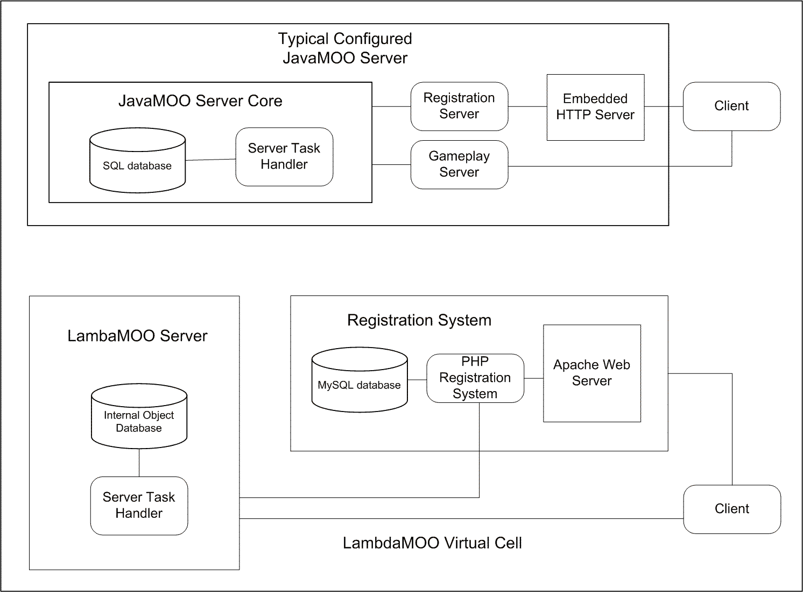
Figure 3: Comparison of LambdaMOO and JavaMOO Server Organization

The New Implementation in JavaMOO

The JavaMOO Virtual Cell system is a reimplementation of the original LambdaMOO based Virtual Cell system. To meet the goals of improved system performance, ease of maintenance, and increased stability, it was natural to redesign certain elements of the system to eliminate various limitations in the original system.
As noted before, JavaMOO and LambdaMOO use different programming languages, and as a result, the system had to be rewritten in Java. This necessity only served to reinforce the desire to redesign certain elements of the original system.

Changes to Modules and Goals
In the original implementation, the sequence of modules for the game, and the sequence of activities or goals for each module, was defined as a simple list. The activities and progress of a player as the player worked through each activity was stored in a history log for that player along with a list of which goals had been completed. This decision was made in the LambdaMOO implementation because of the unusually high cost of object creation in the LambdaMOO system. There were negative consequences that resulted from these choices. The first consequence was that it was difficult to determine which history events represented state information for a goal and which history events were used for generic activity tracking. The second consequence follows from the first and is that it became difficult to support the ability to repeat a module from a fresh start.
During the reimplementation of the goal and history system for the JavaMOO system, the opportunity was seized to restructure the system to support repetition of activities. Rather than attempting to store goal state information in the history system, the new system creates working copies of the master goal objects, and ensures that the state of the working copy accurately represents the player's current progress. This approach was feasible in the new system because of the reduced secondary costs associated with object creation in the JavaMOO system compared to the LambdaMOO system.

Client-side simulations

Naïve finite state simulations
In the LambdaMOO version of Virtual Cell, a series of eight simulations of various aspects of cellular respiration and photosynthesis were implemented on the server side. These actors in these simulations can be divided into 'compounds' which represented the various substrates, ions and compounds in the system; 'item sources' which created the various compounds and acted as points for the compounds to collect; and 'pumps' which both moved the compounds between item sources and optionally transformed and combined the compounds into new compounds as they moved.

Network lag as the enemy of visual quality
During the course of a simulation, one of the common operation sequences was for a compound to be added to the scene and then moved to a different position in the scene before being transformed into a new compound. The client viewed this sequence of operations as the announcement of a new object in the scene, an announcement of the new object's definition, an announcement of the movement, and an announcement of the transformation. Because of natural delays in loading the newly introduced object and setting its geometry, and combined with an attempt for the client to not fall too far behind the server's version of the world, it was not unusual for an object's animation to begin before its geometry was fully loaded.

Re-implementation of the simulations on the client
Client-side implementation of the simulations has several advantages over the server side implementation. First, in the client-side implementation, the various compounds are implemented as purely client-side objects and as a result, the stability of the scenes is improved. Secondly, the simulations were adjusted to generate entire simulation sequences as a collection of animation steps instead of pausing between steps to allow the renderer to catch up. Thirdly, the client-side simulations proved to be more reliable than the server side simulations. A side effect of this change to the animation generation is that the animation steps could be paused, rewound, and watched again without needing to reset the simulation and step through it again.
One complication of the client-side simulations is the need to place a significant amount of the simulation logic for each simulation in the client and then arrange for the client to notify the server as various steps are completed so that the state of the player's goals can be updated.
A second complication of the client-side simulations is that the state of the local simulations is not easily sharable between clients. In the current system, all of the simulations are restricted to single occupancy scenes. However, if it becomes desirable in the future to have multiple viewers of a simulation it will be necessary to implement additional logic to appoint one of the copies as the master copy and synchronize the states of the other simulations to the master copy through sharing of trigger events and synchronization of randomizer seeds.

Informing the server about state changes
The immediate and obvious hurdle when moving the simulations from the server to the client was the task of re-implementing the simulations in the client versions of the scene objects and providing additional infrastructure on the client to carry out the simulation loop and animation updates. A less obvious hurdle was that the goal state information still resided on the server, and so the client-side simulations would need additional instrumentation to ensure that the server would be notified when various events took place.

Flexibility versus complicated scene definitions
The first iteration of the LambdaMOO and JavaMOO Virtual Cell systems both featured a mixed object model where each persistent object in the system had a globally unique ID number. The ID was used to maintain the association between the persistent copy of the object resident on the server and the representation of that object on each of the clients. In the first iteration, any interaction between objects in the system needed to be done by the server implementations of the objects.
In the second iteration of the system, it became expedient for the various client-side objects to communicate directly. The original purpose for this was the implementation of object definition collections, although the client-side simulation system also capitalized on this ability.
In the object definition cache scheme, it was conjectured that all of the temporary object definitions for a level could be loaded when the scene was first accessed in order to eliminate one source of delay in loading dynamically created object geometry. While the proposal to implement a definition cache object and objects that read their geometry definitions from those caches, this did necessitate adding a linking step to the scene loading algorithm.
Compared to the cache system, the client-side simulation system represented an entirely new level of work for the linking system. Instead of one object being linked in only one direction to some number of objects, the client-side simulations ended up requiring a large number of inter-object links.

Instance Factory
The various areas of the Virtual Cell game are defined by scene files, and each instantiation of a particular scene is referred to as an instance. The instance factory is responsible both for locating available existing instances when a player's activities involve traveling to a given scene and also creating new instances of a scene if none of the existing instances can accommodate the player.

LambdaMOO version
The LambdaMOO version of Virtual Cell implements an instance factory which is either an elegant use of frames, or an atrocious hack, depending on whether it is viewed from the perspective of the implementer or the maintainer. As described earlier, LambdaMOO provides Forth-like frame based inheritance and this inheritance is used create instances of a master scene by simply iterating over the scene and its elements creating child frames and performing a simple adjustment of the properties of those child frames to substitute references to the appropriate child frames for references to the parent frames.
In order to explain one of the problems with a long running LambdaMOO system, it is important to explain how LambdaMOO objects are referenced and recycled. At its most basic, the LambdaMOO system supports raw object creation and each newly created object will be ensured a unique integer identifier which will not be reused upon object deletion. However, the raw object creation and deletion is almost never used in practice because of the fear of identifier exhaustion. Instead, the standard object library takes advantage of the ability in LambdaMOO to change an object’s inheritance and type to recycle objects that are no longer needed. Unfortunately, this leads to problems where an object can be created for use ‘A’, references to that object are passed around and stored in various places, and then the original object is recycled and recreated for use ‘B’ without invalidating the original references. This leads to an unfortunate bug where a process can find a reference to the object as it was used for ‘A’, see that the object appears to not have been recycled, and proceed to be apply good programming habits and recycle the object unknowingly for the second time.
This sort of double recycling became a concern in the development of the respiration and photosynthesis simulations. During the execution of each of those simulations, a comparably large number of temporary elements would be added to the scene, passed around between various complexes, removed from the scene and then recycled. Each element had to be tracked in the various lists associated with each complex, and periodically errors would cause a list to improperly retain elements that were no longer present in the scene. Then, when the entire scene was reset, all of the lists of temporary objects would be cleaned out and all of the referenced temporary objects recycled, and that would lead intermittently to a crash in some other random scene when a temporary object unexpectedly became recycled while still in use.

JavaMOO version
The instance factory in the JavaMOO version of the Virtual Cell differs from the LambdaMOO version in that the scene prototypes are stored in XML descriptions of the scene elements rather than cloneable objects. There were a few factors that contributed to this design change. The first was that the ability to construct scenes from external definitions provided a mechanism for authoring and changing scenes outside of the environment. The second was that replication of an existing scene in Java requires much more effort than scene replication in LambdaMOO. In addition, when the JavaMOO version of the system created a new version of the instance from the definition file, the assumption could be made that the scene definition was final and additional information about the scene could be computed to simplify the client-side object handling.
In both of these schemes, the task of gathering a collection of objects with interconnecting references stored in various data structures, extracting those objects into some intermediate format, and then reading that collection of objects into a new database while substituting references to the new objects in place of the old object. The standard LambdaMOO object database possessed a utility for this purpose, and a corresponding JavaMOO utility is simple enough to generate.

Webserver for JavaMOO Version
During the development of the JavaMOO server, it was discovered that it was completely trivial to use the Apache Tomcat server in embedded mode with the JavaMOO server to go way beyond equivalent functionality for the LambdaMOO HTTP servers. Most importantly, since the Apache Tomcat project had a much larger target audience, the Tomcat server provided a fully featured server being maintained and developed by other developers. In addition, as a fully featured Java-based web server, Tomcat provides support for Java Server Pages, and the significance of that is described later.

JavaMOO Virtual Cell's integrated registration system
As noted earlier, the embedded mode Tomcat server provides support for Java Server Pages (JSP). One direct consequence of this feature is that the LambdaMOO Virtual Cell's external login and registration system was replaced by a much simpler JSP based login and registration system in the JavaMOO Virtual Cell. The most important consequences of this is that it eliminated the information duplication in the LambdaMOO Virtual Cell system, and it simplified deployment of the server as a single component.

Other Improvements over LambdaMOO

Fresh starts versus lint collections
The primary defect of the LambdaMOO system as a development environment is a tendency for the object database to collect junk and left over objects over the course of development.
Inability to integrate meaningfully with version control systems
The integration of code from two divergent object databases frequently devolved into dumping the object definition on the one server to a text file, making manual corrections to that text file, and then uploading the modified object definitions to the new server. Frequently, additional unforeseen conflicts would then be discovered and additional time would be required to trouble shoot and patch the newly created object to make it compatible with the new host environment.

Data types and safety
The LambdaMOO and JavaMOO versions of Virtual Cell use different communication protocols between the client and the server to encode events. The directive and command systems for the LambdaMOO version of the system relied on the client and server agreeing on the meaning of the values in each position of the particular directives for functioning. For example, a given directive may be documented as having a specifically constructed list of values as its third argument, but only weak mechanisms were in place to enforce such a construction.
In contrast, the JavaMOO system relies on instances of the MOOEvent class for encoding both directives from the server to the client and requests from the client to the server. The system simply relies on the Java serialization mechanism to encode and decode the events.
Beyond the elimination of parameter mismatches, the change to sending and receiving objects also allows the system to avoid working around data type limitations. For example, in the LambdaMOO system, a table of property name and value pairs is typically represented as a list of those name and value pairs for various technical reasons. For JavaMOO, since both the sending and receiving party simply use the most convenient Java class or type for the data, such as a HashMap or Hashtable.

Improved object usage
The focus of LambdaMOO's object model was on supporting objects that would be used as a component in a scene or that would be subject to player interaction. Because of this focus, while LambdaMOO supports object oriented development and this support works well for several cases, the use of objects to record temporary information, or for general purpose data processing is not well supported. Missing features included both a notion of garbage collection and support for short object lifespans. This becomes especially problematic because LambdaMOO relies on the strategy of loading all objects into memory and expecting the operating system memory management to handle paging. JavaMOO addresses this by supporting two classes of objects. The first class of objects includes those objects that exist only during runtime operation and are not stored in the database. The second class contains the specific objects in the JavaMOO system that are stored and retrieved from the persistent object database. The two categories overlap slightly as non-persistent objects are serialized for storage when referenced by fields in persistent objects.

Changes in Deployment Models
The original deployment model for the Virtual Cell was simply not to have a deployment model for the server and instead operate the server from the lab room at NDSU. Users who wished to use the system were expected to visit the server's website, download and install the Cosmo Player plugin and then download and run the client program.
In the late 1990’s and early 2000’s, support by Cosmo Software became diminished as the company separated from its original parent company and went through a series of acquisitions that effectively ended support for the product. After searching for a more suitable renderer, the project transitioned to using Xj3D as a replacement for its VRML renderer. One positive effect of this transition was that the client program was no longer required the use of a browser and could instead be used as an application.
In 2004, work began on a version of the Virtual Cell server that could be deployed in other locations. As one might expect, this effort experienced numerous issues caused by the change in system requirements including barriers caused by the licensing requirements for MySQL. The conclusion from initial trials was that it would be simpler to install the server software on a minimal device such as a Mac Mini and distribute those configured devices than it would be to distribute installation software and instructions for the various portions of the server software.
As noted earlier, the JavaMOO Virtual Cell eliminates the need for the external support software for the system. Because that external support software is the cause of most of the technical difficulties distributing the system, it would be much simpler to distribute the new server.
One unresolved issue involves the distribution of the client software in school clusters. Zero-configuration technologies, even technologies like Apple's Rendezvous, are not perfect so there is not uncommon to need to specify the server's address either during installation or when the client software runs for the first time. While this does not represent an impossible barrier, it does fall short of an ideal solution—the installation of the server software on a single machine in a computer cluster without requiring the installation of software on the rest of the machines in the cluster.

The Virtual Cell Animations Project
One of the sources of tension in the Virtual Cell project is the conflict between the production of a high quality animation of a process and the production of an interactive simulation of a process.
In the early stages of the project, illustrative animations of the processes were written in VRML using software like Cosmo Worlds and then an equivalent simulation was developed to operate on the server. As the project progressed, the project gained access to better animation software such as Autodesk (formerly Alias Wavefront) Maya.
The availability of this software to the group in 2003 was part of the impetus behind the attempts to increase the animation quality of the simulations in the system. While the Virtual Cell project has continued to work on producing interactive simulations, the Virtual Cell Animation Project has begun producing a series of non-interactive movie style videos that are being made available at http://vcell.ndsu.edu/animations/.

Conclusion
One might ask how big the Virtual Cell system in terms of lines of code. There are approximately 30,000 lines of code in the standard LambdaMOO LambdaMOOCore object database, and the source code for the LambdaMOO interpreter contains approximately 30,000 lines of code. The Virtual Cell LambdaMOO database contains approximately 35,000 lines of code in addition to the code present in the stock database. In comparison, the base JavaMOO system contains approximately 12,500 lines of code, and an additional approximately 11,000 lines of code were added for the Virtual Cell specific server side functions. The Virtual Cell client is an additional approximately 16,000 lines of code, but, unlike the server code, only a portion of the client code needed to be rewritten to support the new server and new animation system.
The grant that funded the conversion of the LambdaMOO Virtual Cell system to the JavaMOO system had three components relating to programming. The first component was the rewriting of the Virtual Cell object library for the JavaMOO system, the second component was the development of client-side animations for the two modules, and the third component was a software testing experiment intended to ensure that the LambdaMOO Virtual Cell and the JavaMOO Virtual Cell were equivalent systems. (El Ariss, 2010). As a result of the software conformance work, we are confident that the three primary game play modules in the JavaMOO Virtual Cell are functioning appropriately.
While the LambdaMOO server was useful in developing the Virtual Cell to initial prototype levels, as our experiences have shown, there are severe limitations to its use beyond the prototype stages of a virtual environment. Switching over to a more modern multi-user server based on the JavaMOO system has improved the system performance, reliability, responsiveness and also reduced the complexity of server installation.

Acknowledgments
Part of the Virtual Cell project was supported by Grant Number R43RR024779 from the National Center for Research Resources. The content is solely the responsibility of the authors and does not necessarily represent the official views of the National Center for Research Resources or the National Institutes of Health (NIH).
The authors of this chapter would also like to acknowledge the work of the numerous students and professors who have worked on the project or participated in testing the software. Thanks to Omar El Ariss, Dr. Dianxiang Xu, and Santosh Dandey for their parts in the recent software testing project and the development of JavaMOO.

References
Curtis, P. (1992). Mudding: Social Phenomena in Text-Based Virtual Realities. In: Proceedings of the Conference on Directions and Implications of Advanced Computing (sponsored by Computer Professionals for Social Responsibility). Berkeley, April.
Omar El Ariss, Dianxiang Xu, Santosh Dandey, Bradley Vender, Phillip Mcclean and Brian Slator (2010) : A Systematic Capture and Replay Strategy for Testing Complex GUI based Java Applications in Proceedings of the 7th International Conference on Information Technology: Next Generations.
Slator, BM, H Chaput. 1996. Learning by Learning Roles: A Virtual Role-Playing Environment for Tutoring. Proceedings of the Third International Conference on Intelligent Tutoring Systems (ITS'96). Montréal: Springer-Verlag, June 12-14, pp. 668-676. ( Lecture Notes in Computer Science, edited by C. Frasson, G. Gauthier, A. Lesgold).
Slator, B. M. (1999) Intelligent Tutors in Virtual Worlds. In: Proceedings of the 8th International Conference on Intelligent Systems (ICIS-99). June 24-26. Denver, CO: 124-127.
Slator, Brian M., Harold Chaput, Robert Cosmano, Ben Dischinger, Christopher Imdieke and Bradley Vender (2006). A Multi-User Desktop Virtual Environment for Teaching Shop-Keeping to Children. Virtual Reality Journal, 9, pp. 49-56. Springer-Verlag.
LambdaMOO version of Virtual Cell (thesis and/or other papers).
VRML. ISO 14772:1997. See also www.web3d.org/x3d/specifications.

New Terms and Definitions

assay | A test or experiment to measure the biological or immunological activity or quality of a sample.
Cosmo Player | A popular VRML browser produced by the Cosmo Software division of SGI in the 1990’s.
Electron Transport Chain (ETC) | The structures and process associated with the synthesis of adenosine triphosphate (ATP) from adenosine diphosphate (ADP).
lac operon | The gene structure associated with transport and metabolism of lactose in Escherichia coli and other bacteria
LambdaMOO | A MUD developed by Pavel Curtis at Xerox Corporation.
LambdaMOOCore | The LambdaMOO core database. Sample or initial object library supplied with the LambdaMOO server.
LPMud | A MUD contemporary of LambdaMOO using a C like interpreted language and possessing less academic influence than LambdaMOO. Developed by Lars Pensjö.
MUD | Multi-User Dungeon (or sometime Dimension). A general term for text based multi-user environments.
photosynthesis | The process of using sunlight to synthesis food.
VRML, VRML97, VRML 2.0, X3D | An open standards file format and run-time architecture to represent and communicate 3D scenes and objects currently maintained by the Web 3D Consortium.
Xj3D | Java-based open source library for rendering VRML 2.0 and X3D.

4. Index Reference List Template

Index Reference List for (book title): “Virtual Immersive and 3D Learning Spaces: Emerging Technologies and Trends”

Term 1: help and information system
- Also known as:
- Similar to:
- Associated in the manuscript with:
- Notable appearances of this term can be found on:
Page - 3
Page -
Page -

Term 2: diagnostic activity
- Also known as:
- Similar to:
- Associated in the manuscript with:
- Notable appearances of this term can be found on:
Page -3
Page -
Page -

Term 3: lab assistant
- Also known as: Lab Guy
- Similar to: taskmaster
- Associated in the manuscript with:
- Notable appearances of this term can be found on:
Page - 4
Page -
Page -

Term 4: mixed platforms
- Also known as:
- Similar to:
- Associated in the manuscript with:
- Notable appearances of this term can be found on:
Page -5
Page -
Page -

Term 5: fantasy environment
- Also known as:
- Similar to:
- Associated in the manuscript with:
- Notable appearances of this term can be found on:
Page -5
Page -
Page -

Term 6: spatial metaphor
- Also known as:
- Similar to:
- Associated in the manuscript with:
- Notable appearances of this term can be found on:
Page -5
Page -
Page -

Term 7: simulated biological process
- Also known as:
- Similar to:
- Associated in the manuscript with:
- Notable appearances of this term can be found on:
Page -5
Page -
Page -

Term 8: incremental loading algorithm
- Also known as:
- Similar to:
- Associated in the manuscript with:
- Notable appearances of this term can be found on:
Page - 6
Page -
Page -

Term 9: caching and animation paths
- Also known as:
- Similar to:
- Associated in the manuscript with:
- Notable appearances of this term can be found on:
Page -7
Page -
Page -

Term 10: computer generated imagery
- Also known as: CGI
- Similar to:
- Associated in the manuscript with:
- Notable appearances of this term can be found on:
Page -8
Page -
Page -

Term 11: rapid prototyping and development
- Also known as:
- Similar to:
- Associated in the manuscript with:
- Notable appearances of this term can be found on:
Page -8
Page -
Page -

Term 12: instance factory
- Also known as:
- Similar to:
- Associated in the manuscript with:
- Notable appearances of this term can be found on:
Page -13
Page -
Page -

Term 13: scene definition
- Also known as:
- Similar to:
- Associated in the manuscript with:
- Notable appearances of this term can be found on:
Page -14
Page -
Page -

Term 14: data structure
- Also known as:
- Similar to:
- Associated in the manuscript with:
- Notable appearances of this term can be found on:
Page -14
Page -
Page -

