WEB-BASED EDUCATION RESEARCH MANAGEMENT SYSTEMS (WERMS)

John E. Opgrande, Brian M. Slator
Aaron Bergstrom, Phillip McClean, Brad Vender, Alan R. White

Computer Science Department
North Dakota State University
Fargo, ND 58102
Contact: slator@web.cs.ndsu.edu

Abstract
The World Wide Web Instructional Committee (WWWIC) is a research group at North Dakota State University dedicated to creating role-based educational games that teach the fundamentals of cell biology (The Virtual Cell), geology (Geology Explorer), retailing (Dollar Bay), and the past (Blackwood) [Slator et al., 99].
This paper explores innovative methods for developing comprehensive research studies using web-based educational research management tools that are focused on determining the viability of “learn by doing” game environments. These tools have been used to develop, coordinate and assess pilot studies for the Virtual Cell Educational Game. One of the more recent Virtual Cell pilot studies was conducted in the fall of 2001, included four institutions of Higher Education, and was conducted with over 1000 introductory Biology. The study sites were designed using a suite of tools known collectively as LAMP, which consists of Linux, Apache, MySQL, PERL and PHP. Additionally, the Virtual Cell Game utilized a LambdaMOO server, JavaScript, JAVA and VRML.

Keywords: role-based learning, assessment research, virtual environments for education, managing research data

Introduction
Pilot studies employ assessment-based research as a means to test hypotheses on the effectiveness of a given treatment by quantifying the changes in subjects due to the administration of the treatment. At North Dakota State University (NDSU) the Virtual Cell project conducts pilot studies each semester in order to gauge the effectiveness on the Virtual Cell game. The studies consist of a pre-treatment baseline assessment in addition to a post-treatment assessment. A comparison of the baseline assessment against the post-treatment assessment is used determines the net effect of the treatment.

Background
The WWWIC research group conducts assessment based research studies as an integral part of their research into intelligent educational media. The research focus on educational games that range in subject from cellular biology in the Virtual Cell [White, McClean & Slator 99] and physical geology in the Geology Explorer [Saini-Eidukat, Schwert & Slator 01] to microeconomics in Dollar Bay [Regan and Slator 02] and history in Blackwood. These studies, conducted as part of research in educational games, provide unbiased data regarding the effectiveness of the games on student learning by comparing baseline and post-treatment assessments [McClean et al. 2001]. During the development of the studies, attention has been focused on the methods used to coordinate the research studies and in the collection of the student assessment data.

These web-based education research management systems (WERMS) consists of web-based interfaces that manage and coordinate the assessment-based research while minimizing the impact on the classroom and allowing subjects to participate during their free time. The Virtual Cell WERMS coordinates independent pilot studies at multiple institutions from the initial registrations through scoring of the assessments, and manages all the user and administrative interactions during the study.

Virtual Cell Background
The Virtual Cell provides students with an immersive 3D world where they are taught various concepts of plant and animal cellular biology. The students are provided with the tools and techniques required for basic Biological experimentation with the goal of students learning how to think and act like Cellular Biologists.
The learning process of the Virtual Cell is designed to simulate the concept of a master-apprentice relationship. While not explicitly explained to the students, they assume the role of an apprentice, and the various characters and tutors within the world provide the insight and guidance of a master. The students learn through investigation how to identify cellular organelles, such as the nucleus and mitochondria, and the molecular functions within the electron transport chain production of adenosine triple phosphate (ATP).

Pilot Study Background
The Virtual Cell pilot studies conducted in the fall of 2001 involved coordinating over 1,000 students. The participants consisted students from classes at four institutions: North Dakota State University, a research intensive PhD granting university; Minnesota State University – Moorhead, a comprehensive 4 year university; Concordia College, Moorhead, a four year liberal arts college; and the North Dakota State College of Science, a two year technical school. Five introductory Biology classes were involved, with each enrolled student required to participate. The students were evenly distributed into one of three treatment groups (a Virtual Cell group, a web-based group, and a textbook group) based on the students computer competency, students gender and whether or not the students had prior biology lab experience. In all three treatments, the students studied the structures and functions of cell organelles and the Electron Transport Chain.

Implementation
The Virtual Cell WERMS sites were built using the LAMP suite of technology, which is composed of Linux, Apache, MySQL and PHP or PERL. The MySQL database stores all the student study data, such as student assessment data, study assignment details and study evaluation data.
The Virtual Cell Game is built on three technologies: 1) a LambdaMOO server, which consists of a server and a database which contains all the data from the Virtual Cell game and manages all the player interactions; 2) a Java graphical user interface (GUI); and 3) a VRML world and objects along with the Cosmo VRML browser [Opgrande et al. 03]. When a student loads the Virtual Cell Game Client, they are presented with a three-panel GUI. Two of the panels are Java windows and the other is a browser window with the Cosmo VRML plug-in presenting a three dimensional (3D) rendering of the world based on the VRML data sent from the LambdaMOO server.
Additionally, every action, reaction, communication and movement with the Virtual Cell game is logged against the student account. This provides one of the most important and interesting aspects of the Virtual Cell, the ability to fully and faithfully recreate any students experience in the game.

Student Site
To begin the students register and complete both a computer literacy survey and pre-assignment assessment (see Figure 1, below) during the first 4 four weeks of the semester. After four weeks, the students were sorted and placed into one of the three treatment groups: a Virtual Cell assignment group, a web-based assignment group, and a textbook assignment group; Again this was based on the students computer literacy score, gender and previous biology experience, as described above. The assignment portion of the study was available to the students during the fifth and six weeks of the semester, during which time the students learned the structures of the plant and animal cells along with cellular processes.
The three treatment assignments covered similar topics but differed in the methods used to teach those topics. The students assigned to the Virtual Cell assignment group were required to play the Virtual Cell game; the web-based assignment group was required to visit and review assignment related websites; lastly, the textbook assignment group was required to read additional material from a textbook. Both the web-based group and the textbook group were given a quiz at the end of their respective assignment as an incentive to convince the students to review the required materials.
Immediately following the assignment, the students provided feedback about the assignment. In the seventh week of the semester, the students completed a follow-up computer literacy survey and the post-treatment assessment. After the completion of the study, the assessments were graded and the pre-assignment baseline and post-assignment score were compared between groups to determine the effect of the Virtual Cell in the “learn by doing” experience as compared to the textbook and the web-based reading assignments. [McClean et al. 01]

Scenario-Based Assessments
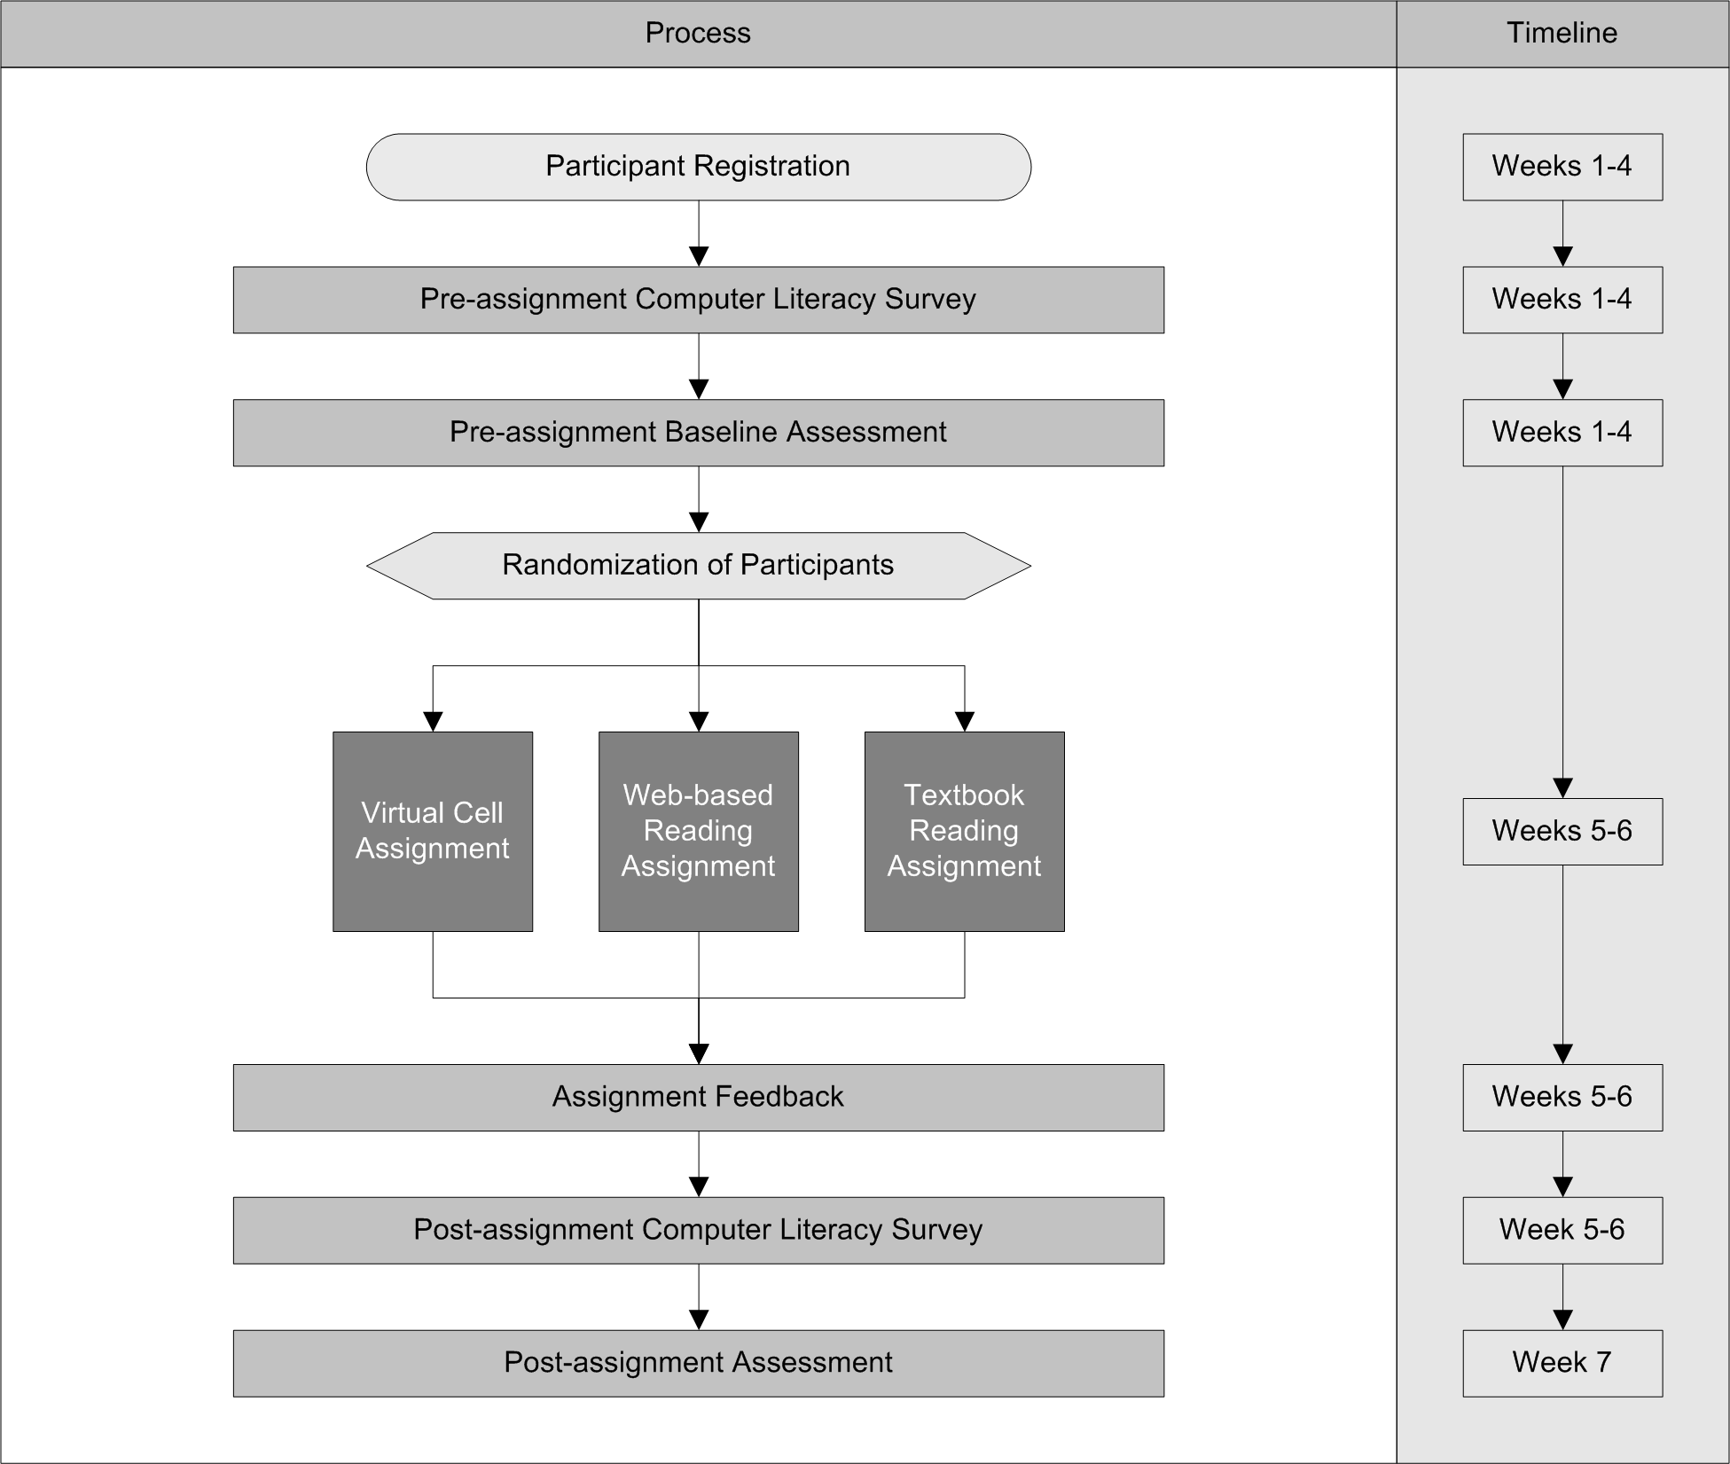
Scenario-based assessments provide the foundation of the research conducted by the Virtual Cell. The assessments provide students with authentic situations through which the studies are able to determine the effectiveness of a given treatment. Scenario-based assessments are useful in comparing student performance against roles and tasks, calculating a quantifiable score and in developing a structured approach to can be consistently applied to treatment groups. Additionally, the assessments are useful in determining true competency of the students, as “There is a close relationship between truly understanding a concept and being able to transfer knowledge and use it in new situations“ [Shepard 2000].

Student Site (student experience)
The student sites provide a unified area where students are provided with a listing of activities they are required to complete during the course of the given study. It is important to note that a key requirement for the development of the student sites was to make the technology transparent to the students in the study.
The WERM system provides the foundation of the Virtual Cell pilot studies, which consists of six ordered activities that each student is required to complete in order. Except for the post-treatment assessment and the study assignment, which are available to students only during specific periods in the semester, coinciding with when the related topics are being taught in the classroom. If the student fails to finish post-treatment or study assignment during the allotted time-period, they are forced to move on to the next activity. The activities are completed in this order:
1. Pre-treatment computer literacy survey,
2. Pre- treatment content assessment,
3. One of three treatment assignments (Virtual Cell experience, Web-based browsing and quiz, or Textbook reading and quiz),
4. Post-treatment user feedback survey,
5. Post- treatment computer literacy survey, and,
- Post- treatment content assessment.

A student enters the pilot study by visiting the Virtual Cell pilot study site and registering. The registration process consists of three steps. In the first step, the student is presented with a list of the institutions currently participating in the study. The student chooses the appropriate institution, and then proceeds to the next page of the registration process. Next, the student enters his/her name, email, selects and confirms a password, provides his/her student ID number and choices the class in which he/she is enrolled (the class list is generated from the collection of institution choices). Lastly, the student finishes the registration process by submitting the data, after which, the student is presented with a response detailing his/her account information. Next, the student is asked to begin the first activity of the pilot study.
The first activity of the pilot study is a 24-question computer literacy survey which is used to place the students evenly among the treatment groups. The first 20 questions are used to determine the student’s comfort level with various computer related technologies, such as the World Wide Web, chat rooms, and playing games. The last four questions ask the student his/her age, gender, college class, and whether or not he/she has previously taken a biology lab course. Two examples of the first 20 questions are:
Question 1: I have used a computer to: (mark all that apply): A) Play games, B) Browser or “surf” the WWW, C) Download files or graphics images, and/or D) Access on-line syllabus, class notes, homework or other school assignments.
Question 11: How comfortable are you with using computers for doing homework or other school assignments? A) Not at all, B) Moderately, c) Very.
The exact details of how the students are distributed amongst the different experimental groups is discussed later, however, it is important to note that between each group there is an equal distribution of:
- students skill and comfort with hardware and software;
- Male and female participants; and
- Students who have prior biology lab experience.

Once the student completes and submits the pre-treatment computer literacy survey, the student is forwarded to the student activities page. Also, every time students log into the pilot study, after the initial registration, they are presented with their personalized activities page. The activities page provides the students with a list of all the activities in the study and shows the status of each. Activities that a student has completed appear grayed out with a checkmark next to the activity name. The current activity is active and clickable and, if it is a time sensitive activity, shows the end date. All uncompleted time sensitive activities either have a start date or an end date depending on whether the start date has passed or not. Also, once the students have been assigned to their treatment group, the activities page provides them with a list of assets specific to the assignment. Another important feature of the activities page is the ability for the instructors and study administrators to include messages to the students on the activities page. The message may be specific to the treatment group or shown to the whole study.
Whenever students who have not completed the pre-treatment computer literacy survey or pre-treatment assessment visits the activities page, they are presented with a popup alert message that states: “Please complete the Survey 1 and Pre-Test Scenario as soon as possible. See the instruction for more information”. This was introduced after it was found that many students were not completing the pre-treatment survey and the pre-treatment assessment in a timely manner, usually after assignment was scheduled to begin. This caused problems since the students could not be divided with the other students into the treatment groups, which necessitated their being placed in the default group and marked as not grouped. In addition, students not completing the assessments in a timely manner were farther along in the class lectures when they completed the assessment activity, resulting in the removal of the students from the study analysis to prevent the skewing of data.

The Assessment Protocol
The assessment protocol designed for the Virtual Cell and all WWWIC projects is a qualitative one that seeks to measure how student thinking has improved. All students are asked to answer open-ended scenario-based questions before and after the experiment. These scenario questions are word problems that present the student with a situation with which a practicing biologist might be confronted. Students respond to the questions with narrative answers, which are evaluated according to an established protocol. The pre-treatment assessment for the fall of 2001 is as follows:
“You are on a foreign fellowship to work with Dr. Larsson in Sweden. Dr. Larsson is a cell biologist who specializes in human diseases. A new group of patients arrived recently exhibiting myopathy, severe muscle weakness. The most prominent symptom is severe muscular weakness after just a short period of exercise. Using his vast experience with cellular diseases, Dr. Larsson immediately suggests the Golgi apparatus is not functioning properly. This strikes you as not quite right. You suspect another organelle is not functioning correctly. You quickly volunteer to test Dr. Larsson's hypothesis. Describe the experiment(s) you would perform to demonstrate which organelle is not functioning properly.”
The students are then asked to “List the questions you would ask yourself, give the reason behind those questions” and “List the things that you would consider when designing the experiment(s)”.
Each student is assigned to one of three treatment assignments: the Virtual Cell, the web-based assignment, or the textbook assignment. The assignments are designed to cover comparable material and differ only in the methods of presentation. The textbook assignment expands on the normal class readings and requires the students to review additional sections of the class text. For the web-based assignment has, the student visits additional websites. The students assigned to the Virtual Cell treatment are required to complete the Virtual Cell game assignment. After the students are assigned to a treatment group, the students are presented with a list of assets, specific to that treatment, to help the students complete their assignment. The textbook assignment provides the students with a list of pages from the class text that the students need to review as part of the assignment. The web assignment provides the student with links to the additional web sites that the students re required to review. Lastly, the Virtual Cell assignment provides the students with a tutorial demonstrating how a person moves around in a virtual world, a link to the Virtual Cell FAQ, and a link to the help message board.
Students assigned to the textbook and the web assignments are required to complete a quiz covering the materials from the respective assignment as the final part of his/her study assignment. A student participating in the Virtual Cell assignment completes his/her assignment when he/she finishes all of the modules in the Virtual Cell game.
After the students finish their assignment, they are next asked to complete a multiple question feedback form with questions specific to the assignment. The students are given several multiple choice questions asking the students’ opinion on specific questions which relate to the usability and effectiveness of the Virtual Cell study. In addition, the students are provided with an open form question where they can address any additional issues not covered specifically in any of the other questions.
The Virtual Cell assignment feedback is composed of 30 questions, while the text assignment and web assignment feedback have 15 and 16 questions respectively. Each question on the text and web assignment feedback forms corresponds to one of the question on the Virtual Cell feedback form. This provides the means to correlate the feedback across the different delivery methods. As an example, both the first and second questions asked in all three assignment feedback questionnaires are related. The student is asked to answer the following questions using a scale of 1 to 5:

Q1.(web & text) The questions were difficult to understand ~ The questions were simple to understand.
Q1. (VCell) The game was complex to learn ~ The game was simple to learn.
Q2. (web & text) The answers were difficult to find ~ The answers were easy to find.
Q2. (VCell) The game was difficult to operate ~ The game was simple to operate.

The post-assignment computer literacy and the post-treatment assessment are identical to the pre-assessment computer literacy survey and assignment assessment, except the post-assignment assessment has a different narrative than the pre-treatment assessment. The post-treatment assessment, for the Fall of 2001, reads as follows:
“You are on a foreign fellowship to work with Dr. Rotig in Germany. Dr. Rotig is a cell biologist who specializes in human diseases. A new group of patients arrived recently exhibiting heart myopathy, a severe weakness of the heart muscle. The most prominent symptom was shortness of breath after a brief period of exercise. Using his vast experience with cellular diseases, Dr. Rotig immediately suggests the Golgi apparatus is not functioning properly. This strikes you as not quite right. You suspect another organelle is not functioning correctly. You quickly volunteer to test Dr. Rotig's hypothesis. Describe the experiment(s) you would perform to demonstrate which organelle is not functioning properly.”

As noted before, the students are allowed to complete the post-treatment assessment only during specific dates. If students visit the pilot study during a period in which the post-treatment scenario assessment is available, they are allowed to complete the assessment and finally complete the pilot study. However, if students return to the pilot system, after completing all other activities yet before the specified date, the system informs the student that they may not continue to the post-treatment assessment until the specified date. In addition, if the students’ returns after the closing date of the pilot study, they are informed that the study has ended.

Virtual Cell Administrative Site
An administrator who logs into the Virtual Cell administration site is provided with a summary of all classes that are currently participating in an active pilot study along with the start and stop dates for each study activity and the number of students enrolled. From this summary, the administrator can perform any one of the many administrative tasks. The tasks provided on the administrative site are: create a pilot study; add, update or delete an institution or class; add or update a faculty member or student; and lastly, distribute a set of students into the assignments groups.
The first task, setting up a pilot study, is accomplished in one of two ways. The first happens when a new faculty member visits the Virtual Cell website and requests that a pilot study be setup for his/her classes. When a faculty member submits the class request, an email is sent to the administrators notifying them of the new pilot study request. In the email, the administrators are provided with a direct URL link, corresponding with the class request. When the administrator clicks on the link, the new class request form is shown. From here an administrator, can either accept the request and create the class or deny the request and delete the data. When the administrator adds a class to a new study, they are provided with the opportunity to fine-tune the details of the study. Administrators who choose to fine-tune a study are directed to the class modification form, where they are able to define for example, the start and stop date of each aspect of the class’s study, add any important announcements and define the study group’s details.
All data pertaining to institutions and classes can be edited at this point also. From the class details page, the administrator can view a list of all the students belonging to that class. Each student is selectable, and the administrator may access all students’ details, such as the students ID, login, password, and email address. This allows the administrator to update a forgotten password, change an email addresses or any of the other account information.
One of the most important tasks in administering a pilot study is evenly distributing the students of a class into the different treatment groups. The distribution of the students is done by first selecting all the students from the class along with the student’s pre-treatment computer literacy data from the MySQL database. As described earlier, the data for the computer literacy survey consists of the student’s login id and a record for each of the 24 questions in the computer literacy survey. Once all the students are selected, the score of each student is calculated based on the following formula. In the first three questions, each with four answers, every answer selected adds one point to the student’s score. If the student selects A, B, and D he/she receives 3 points, for a possible 12 points for the first three questions. Next, the next 16 questions are scored, with the following scoring: answer one (“Not at all”), worth zero points, answer two (“Moderately”), is worth one point and answer three (“Very”), is worth two points. The 16 questions are totaled for a maximum of 32 points. The results from the two sections are totaled.
Lastly, the students are divided into four groups based on first, the student’s gender, and then whether or not the student has had prior biology lab experience. The students are then sub-divided again based on the score calculated earlier. For the Pilot Study conducted in the fall of 2001, the students were divided into male and female groups. Both groups were sub-divided into those who have taken a biology lab course and those who have not, followed by each subgroup further divided into three assignment groups (as seen in Figure 2).

Female Students |  | Male Students
With Prior Biology Course | Without Prior Biology Class | With Prior Biology Course | Without Prior Biology Class
Text | Text | Text | Text
Web | Web | Web | Web
Virtual Cell | Virtual Cell | Virtual Cell | Virtual Cell
Figure 2. Virtual Cell Assignment Distributions

Grading Site System
The Virtual Cell Pilot Study uses scenario-based assessments to study the effectiveness of the Virtual Cell study treatments on student learning. The pre-treatment assessments scores are compared with the post-treatments assessment scores of each student to determine a given treatment’s effectiveness.
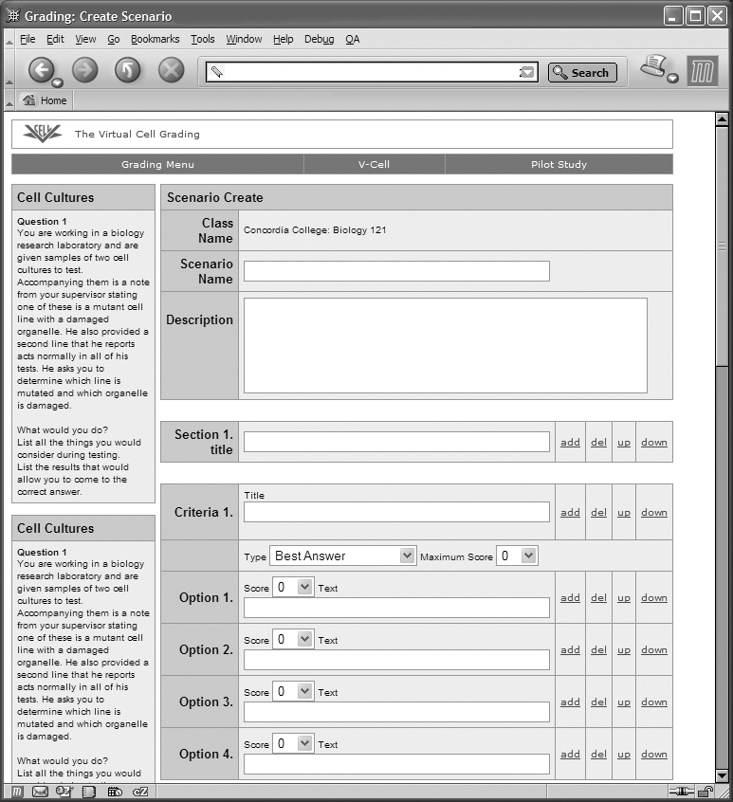
The Virtual Cell grading suite provides the means to develop, update and score assessments, train graders, and lastly, export the data for further analysis. Graduate students in the NDSU Biology department grade the pilot study assessments according to defined grading rubrics form.
To create a new grading form the administrators select a class, and then are given a default rubric template for the new grading form which consists of three sections, with three criteria, two criteria and one criterion respectively, each criterion consists of four options. The administrator is then able to add or remove criteria and options as required (see figure 3). Each criterion can be of one of three types. The first type is “choose the best answer”, which allows the grader to choose one of the possible answers. The second type is “choose all that apply”, which allows the grader to choose all the answer that fits the grading criterion. The last type is “choose a point value on the scale”, which allows the grader to determine how many points to assign each answer. Next to each criterion option, is a place to type the option name and give the option a score for choosing that option. Each criterion is also given a maximum score allowed; this is useful for the “choose all that apply” answers, which may exceed maximum score allowed, in some combinations. In the end, all the criteria maximum scores are tallied to create a maximum total for the entire grading form. The Virtual Cell assessments are typically scored on a scale of 0 to 100, where a score of 100 would be expected from a PHD biologist.

Grader Training
The administrator begins creating a training assessment rubric form by choosing the class assessment. The administrator is then presented with an assessment grading form setup (described previously), which allows the administrator to create a form identical to the normal grading form, except this form is designated for training that assessment.
After the creation of the training form, the administrator is asked to enter sample grading assessments that will be used to train the graders. When entering sample assessments the administrator uses the newly created form to establish the correct values for each training assessment, along with at the end of each criterion, a space for the administrator to explain the grading analysis.
Before graders are allowed to grade actual student assessments they are required to complete a training session of 25 sample students with a .75 correlation between the standard and trainer which is calculated against the total scores. The purpose of the training is to ensure statistically similar grading results between graders. The correlation is calculated by the following formula in Figure 4.
$r=\frac{\sum_{i=1}^{n}{\text{Xn}∗\sum_{i=1}^{n}{\text{Yn}}}}{\sqrt{\sum_{i=1}^{n}{{\text{Xn}}^{2}∗\sum_{i=1}^{n}{{\text{Yn}}^{2}}}}}$$\text{where }Xn=xn−\bar{x}\text{ and }Yn=yn−\bar{y}$
Figure 4. Correlation Formula

The grader begins training by creating a new training session, and is able to create new training session as desired, although each grader is limited to only one training session at a time. . Once a grading session begins, a list of all samples, graded and un-graded is presented to the grader. The grader selects an un-graded sample to begin the grading process. The training for grading process is identical to the grading process of the actual student samples, except that when the grading rubric is submitted, the grader is provided with a critique of his/her grading. The critique provides an explanation of the correct grading criterion, as entered during the sample grading by the administrator, explaining what the correct answer or answers are and description of why the answers where chosen. Each grading is saved for future reference and is used to determine the correlations. Once the grader completes the session, the statistical correlation of that session is calculated according to Figure 4. If the session has a correlation higher that 0.75, they are prompted to begin grading. If unsuccessful, they are asked to begin another training session and undergo the training again. At any time after grading a training sample, the grader can return and review the critiques of that sample from the most recent training session.

Assessment Grading
The grader begins grading by choosing a class. Once the class is selected, a list of all available assessments belonging to that class is presented. Scenarios where the grader has successfully completed a training session are available for grading, where as scenarios that have either not completed a training session or have not achieved a sufficient correlation value are noted as such. Upon choosing an active grading assessment, the grader is presented with a randomly ordered list of un-graded students. When the graders choose a student to grade, they are presented with a review of the assessment and the student’s response along the left side of the grading form. The grader reviews the assessment and the student’s response, and completes the grading rubric form by answering each criterion.
When the grader chooses a criterion scoring option, that score is added to the running total of that criterion and form total. The grader is required to answer each criterion before submitting the grading form. If a grader attempts to submit the form without scoring each criterion, messages alerts the graders of the un-scored criterion and requests they score that criterion and then re-submit the form. Upon submission, a review sheet is presented to the grader showing that the grade has been successfully entered. At this point, the grader may either correct submitted scores or move on to grade other samples. This pattern continues until all samples are graded.

View Grades
The last option available in the grading system is the ability to view graded scenario assessments. Each grader is provided with the ability to view any assessment that he/she graded, whereas the site administrators are allowed to view all the graded assessments. The assessments can be set to download into a spreadsheet program, such as Microsoft Excel.

Virtual Cell Faculty Site
All faculty members involved in a Pilot Study are provided access to a secured area that enables them to access the faculty site. The faculty site provides them with a list of the classes currently participating in a study along with a detailed summary for each student involved. The summaries provide the faculty with a list of the students registered for given pilot study, along with the student’s name, student’s school id, status of each study activity, and the Virtual Cell assignment score, for each student participating in the Virtual Cell assignment.
The faculty summary information is similar to the pilot study summary found in the administrative site, the only difference is that the individual student activity entries are not provided to the faculty.

CONCLUSION
The development of systems that enable researchers to conduct their studies over the Internet has become a hot area of research. By implementing these systems the Virtual Cell has grown from conducting paper-based studies at a single institution to successfully conducting studies at four institutions with over 1000 students a semester, while achieving the goal of minimizing the impact these studies have on the classroom.
In some respects, the study systems described here resemble Internet based course management software, however it is different in many aspects. The first, as seen in the Virtual Cell Pilot Study suite of tools, is that the students that register for the Virtual Cell WERM System are required to complete a computer literacy survey, which is used to create balanced distributions of students among the study groups. This is a fundamental requirement of any scientific study.
Additionally, the students complete pre-treatment and post-treatment assessments that are used to study the effect of the treatment on the students’ understanding of the biological process taught in the study. The conducting of the assessments itself is not unique, however, the methods in which the assessments data is scored by trained graders is. The assessments are graded against a standardized set of criteria, which when tallied is used to correlate the pre-treatment and post-treatment assessments. In addition, graduate students for the Biology department, who are trained and have established a correlation of greater than 0.75 between the standard scoring and his/her assessment grading scores on a sample set of scenario training data, grade the assessments. This is important, as the 0.75 correlation shows that the graders have been trained to the point where the scores between the graders and the standard scoring can be viewed as statistically equivalent.

ACKNOWLEDGEMENTS
The NDSU Worldwide Web Instructional Committee (WWWIC) research is currently supported by funding from the National Science Foundation under grant EIA-0086142, and from the US Department of Education under grant P116B000734.

REFERENCES
[Saini-Eidukat, Schwert & Slator 01] Saini-Eidukat, Bernhardt, Donald P. Schwert, and Brian M. Slator. (2001). Geology Explorer: Virtual Geologic Mapping and Interpretation. Journal of Computers and Geosciences. 27(4)..
[McClean et al. 01] McClean, Phillip, Bernie Saini-Eidukat, Donald Schwert, Brian M. Slator, Alan R. White. Virtual Worlds in Large Enrollment Biology and Geology Classes Significantly Improve Authentic Learning. In Selected Papers from the 12th International Conference on College Teaching and Learning (ICCTL-01), Jack A. Chambers, Editor. Jacksonville, FL: Center for the Advancement of Teaching and Learning. April 17-21, pp. 111-118. 2001
[Opgrande et al. 02] Opgrande John E., Brian M. Slator, Aaron Bergstrom, Phil McClean, Bradley Vender, Alan R. White (2002). “Coordinating Pilot Studies for Distributed Learning Environments with Web-based Support Tools.” Proceedings of the International Conference on Information and Knowledge Sharing. St. Thomas, VI: November 18-20, pp. 83-88.
[Regan and Slator 02] Regan, Patrick M. and Brian M. Slator (2002). Case-based Tutoring in Virtual Education Environments. ACM Collaborative Virtual Environments. Bonn, Germany. Oct. 1-3
[Shepard, L. 02] The Role of Assessment in a Learning Culture: Using Assessment in the Process of Learning. ER Online; October 2000. http://www.aera.net/pubs/er/arts/29-07/shep09.htm accessed March 5 2003.
[Slator et al., 99] Slator, B.M., Juell, P., McClean, P.E., Saini-Eidukat, B., Schwert, D.P., White, A.R., and Hill, C., 1999, Virtual environments for education: Journal of Network and Computer Applications, v. 22, p. 161-174.
[White, McClean & Slator 99] White, Alan R., Phillip E. McClean, and Brian M. Slator. “The Virtual Cell: An Interactive, Virtual Environment for Cell Biology. World Conference on Educational Media, Hypermedia and Telecommunications (ED-MEDIA 99), June 19-24, 1999 Seattle, WA, pp. 1444-1445.

